Linux Hardening & Patching
Step 1. Verify OS Details
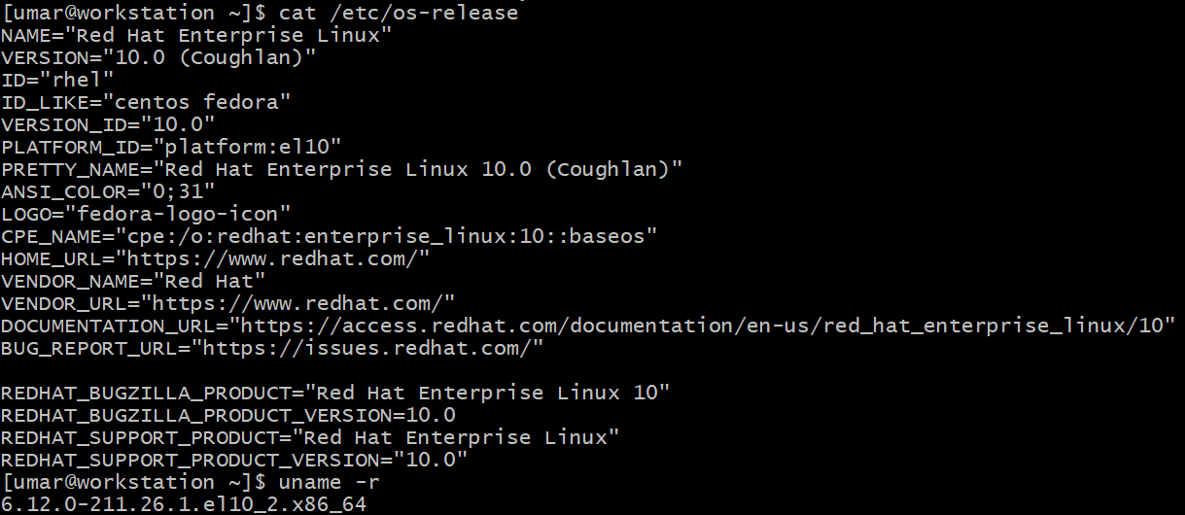

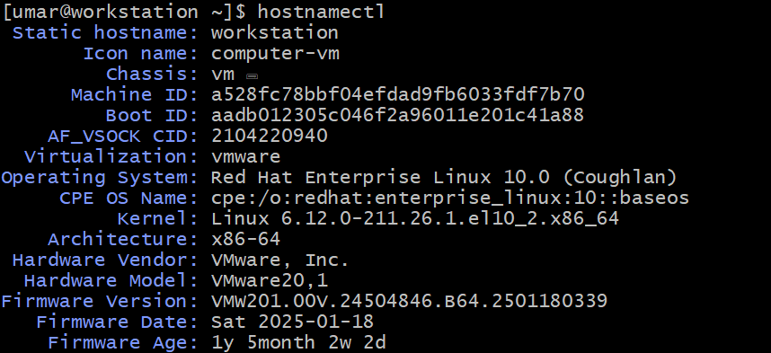

Step 2. Verify Existing Users
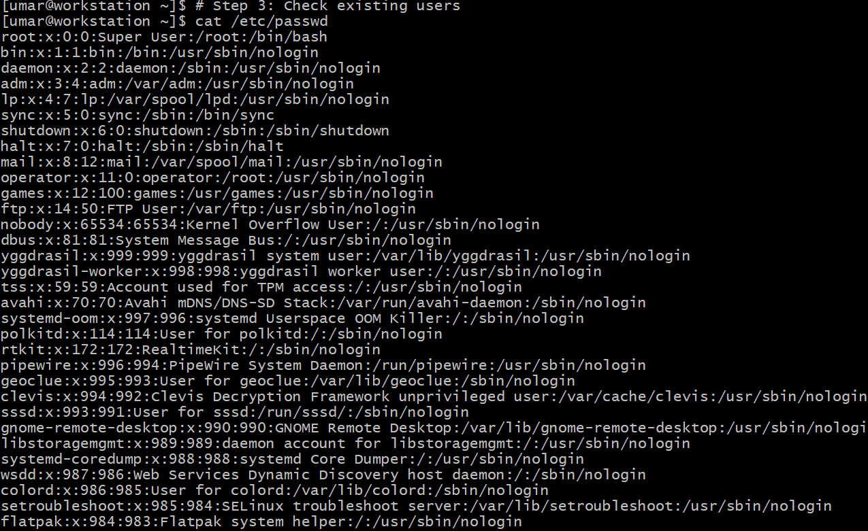
Step 3. Configure Password Policy

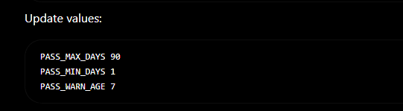

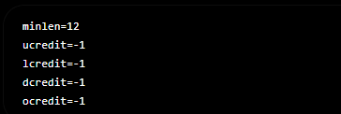

Step 4. Secure SSH
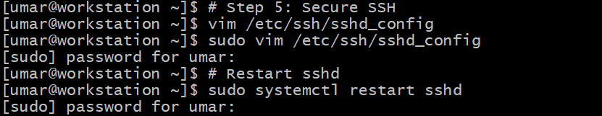
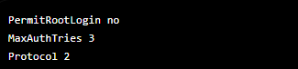

Step 5. Enable Firewall
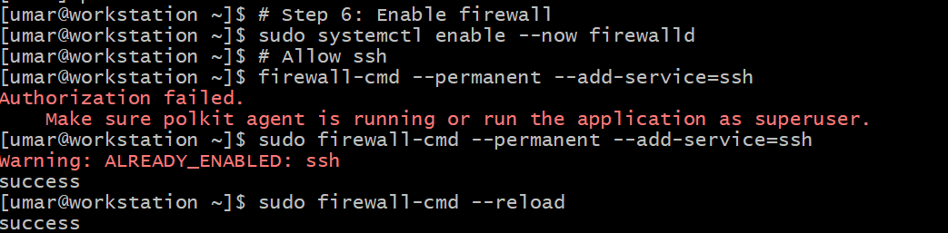

Step 6. Enable SELinux


Step 7. Enable Auditing
